Pure Storage (PSTG)
Category: Storage
Est. Price Per Unit: ~$150k+ per FlashBlade

What They Do

Product 101 and Where They Fit into the AI Stack
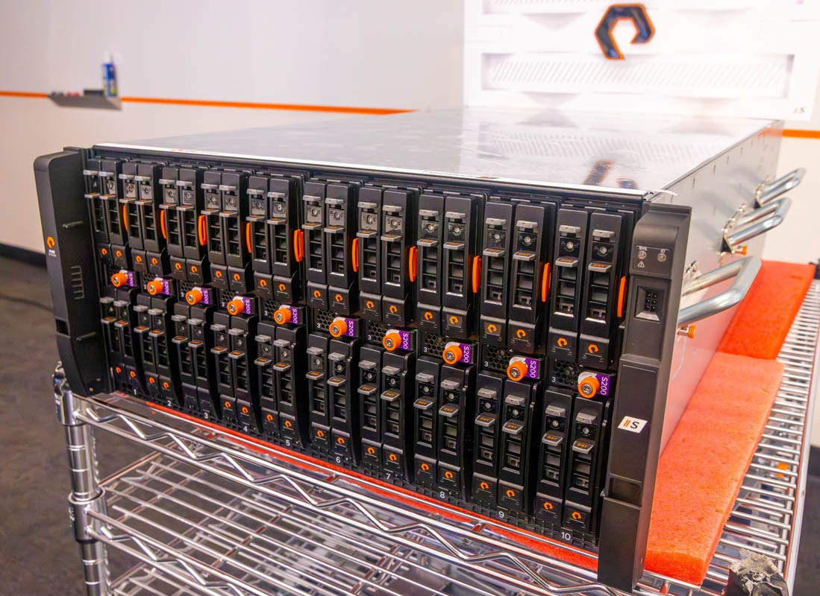
Pure is often thought of as a commodity hardware vendor. The thesis is that it's actually a software company wrapping proprietary hardware to solve two constraints in the AI era: power and predictability.
The key differentiator is DirectFlash. Competitors (NetApp, Dell) buy pre-packaged SSDs from Samsung/Hynix with their own internal controllers doing garbage collection and wear leveling independently. Pure buys raw NAND chips and manages them via software-defined controllers at the system level. This is somewhat analogous to Groq's method for inference chips with deterministic software defined networking.
This architecture has three implications:
Power/density: removing individual controllers reduces power/TB by ~50%. They ship 75TB modules with a roadmap to 300TB.
QLC economics: Pure can use lower-cost, lower-endurance QLC NAND but achieve TLC-level reliability because their software manages writes globally, preventing uneven wear.
Deterministic latency: no random latency spikes from SSDs doing their own maintenance. Critical for keeping GPUs fed without tail latency stalls.

Alignment with Overall Thesis
As LLM context windows grow (1M+ tokens), GPU HBM is too expensive to store the full KV cache. Pure allows offload to local flash with low enough latency to prevent stalls—effectively RAM expansion for inference.
In training clusters, if one storage node hangs, the entire GPU cluster waits. Deterministic latency maximizes GPU utilization.
For RAG architectures in finance/gov, indexing proprietary data on-prem avoids cloud egress fees and regulatory risk.

Business Model, Customers
~$150k+ per blade. Bought when data buckets fill up.
Evergreen subscription model: unlike competitors requiring forklift upgrades every 3-5 years, Pure upgrades controllers non-disruptively with replacements
Pure isn't trying to beat AWS/Azure at general cloud storage. They're the premium tier for difficult workloads that customers don't want on the cloud for security, speed, or egress fee reasons. Pure's common customers are government departments, financial institutions (many trading firms with latency requirements), and customers with sovereign data requirements (increasingly common)
Meta's AI Research SuperCluster uses Pure. Anecdotally, Meta may significantly expand contracts with Pure. Google Distributed Cloud (reportedly Google's fastest-growing division) partners with Pure and also confirms the tailwinds of hybrid and on-prem 'cloud' solutions (GDC is outpacing all other GCP divisions). GDC, for example, will partner with Pure as the foot in the door hybrid cloud vendor, and then GCP can offer the remaining on-prem solutions.
RPO growth (24%) is outpacing revenue growth (17%)—signals a backlog of large commitments (even before the Meta upgrade)
Acquired Portworx, the leading Kubernetes data layer. Gives Pure a software hook into applications, not just hardware.
Competitive context: NetApp is software-on-commodity (bound by Samsung/Kioxia physics). Hyperscaler native storage is "good enough" but IOPS/$ is poor. DIY NAND is theoretically possible but building an enterprise-grade flash translation layer took Pure 10+ years.

Comments on Team
Founded in 2009.
Founder is now Chief Visionary Officer and Director.
Other co-founder is an advisor.

Early View of Moat Hypothesis
10+
years of flash translation layer IP. Building an FTL that handles QLC reliability at enterprise level is non-trivial.
Evergreen subscription creates switching costs.

Why They're Interesting, and Why Now
The thesis shifts from "storage for databases" to "storage for AI context." We have to believe AI inference moves on-prem and hybrid—if that plays out, Pure becomes a hyperscaler partner rather than competitor.
1M+ token LLMs need KV cache offload. Pure's low-latency flash could serve as HBM expansion, though this use case is still emerging.
Data center power is the new bottleneck. Pure's 50% power/TB advantage is tangible and measurable.

Enterprise AI Storage: Qualitative Signals
Enterprises are starting to think about storage more strategically for AI workloads. This is a shift from storage as commodity infrastructure to storage as a performance-critical component of the AI stack.
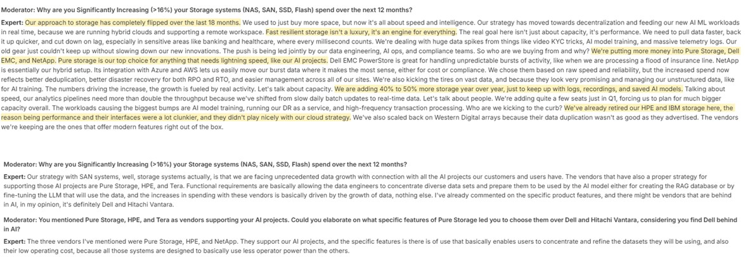

Key Risks
If standard SSD controllers improve enough to handle QLC reliably, Pure's margin advantage erodes.
If AI inference moves entirely to memory-heavy chips (Groq, Cerebras) that don't need storage offload, the AI tailwind
weakens.
Customer concentration—heavy reliance on Meta and potentially 1-2 others creates binary risk.

Gaps in Understanding / Key Questions
How defensible is FTL IP if Samsung/Kioxia invest heavily in controller software?
Depth of Meta relationship—is Pure truly tool of record or one of several vendors?
Portworx adoption—is Kubernetes storage actually sticky or commoditizing?

Select Financial Graphs

R1: Total Revenue & YoY Growth
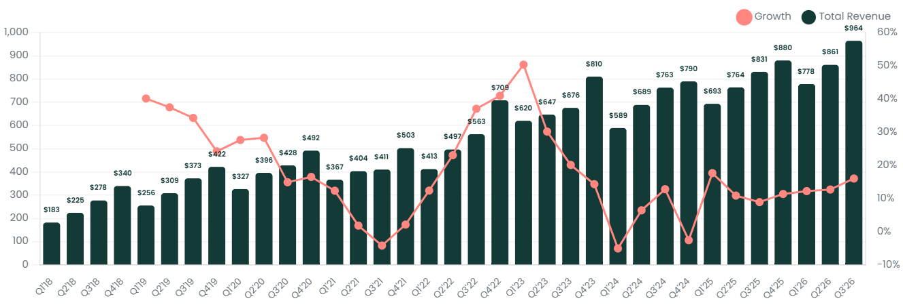

R3: LTM Revenue Growth (Total, Product, Support)
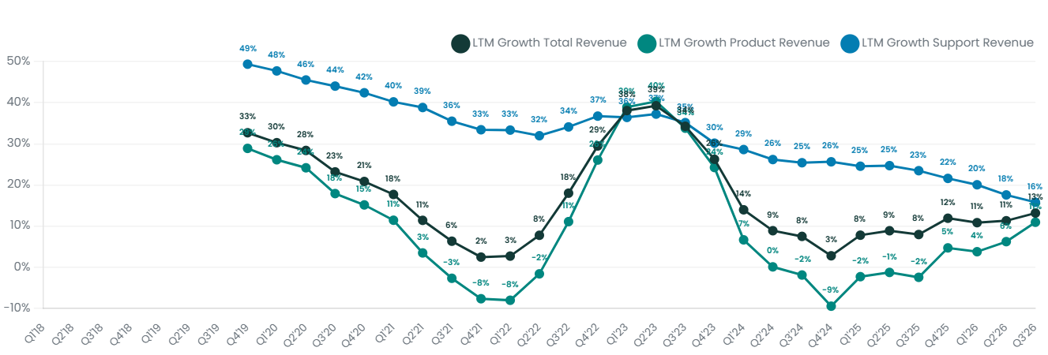

I1: Inventory Turns
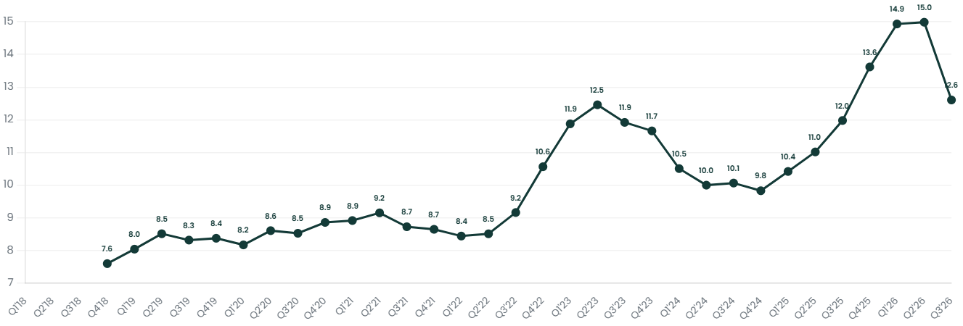

SUB2: Total RPO & YoY Growth
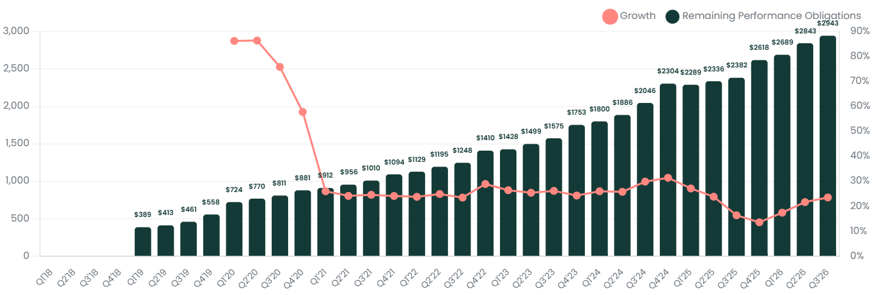

SUB3: RPO vs Revenue vs Support Growth
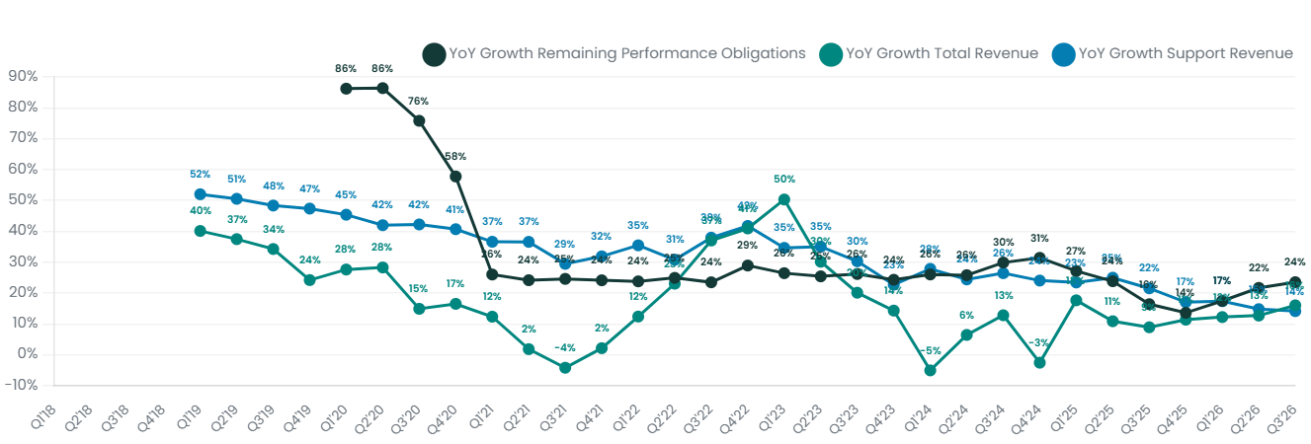

V1: EV/Sales NTM
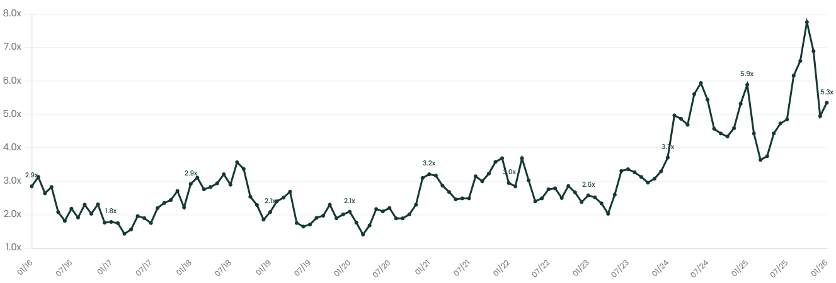

Patent Analysis

Storage Software Innovation Leader
Pure Storage shows exceptional patent citation rates—peaking at 178 citations/patent in 2020 (extremely high). This suggests their flash translation layer and storage software IP is highly influential and frequently referenced by others in the industry.
“Patent analytics/30_pure_storage.png” could not be found.

Interesting Topics to Read
DirectFlash vs. commodity SSD architecture
QLC vs. TLC NAND economics and reliability
KV Cache offload for large context LLMs
Pure Evergreen subscription model
Portworx and Kubernetes storage
NetApp competitive positioning

